Red Hat Identity Management
Service Design Document

Version 1.2

Version History
Version Number | Date | Author | Summary of Changes
1.0 | 4/9/2015 | Dan Rohr | Initial draft
1.1 | 4/22/15 | Dan Rohr | Updated Appendixes
1.2 | 8/3/15 | Dan Rohr | Formatting Updates
Table of Contents

1Introduction 5
1.1Service Overview 5
2Operating System Version 6
2.1Build Version 6
2.2Software Installed 6
2.3Patch Baseline 6
2.4Configurations 6
2.5Hardware Assumptions 7
3FILE SYSTEM 8
3.1File System 8
3.2Swap Space 8
3.3Linux Kernel Crash Recovery Service 8
4NETWORK 9
4.1Drivers 9
4.2Number of Interfaces 9
4.3Virtual Local Area Networks (VLANs) 9
4.4High Availability 9
4.5Network MTU Settings 9
5STORAGE AREA NETWORK (SAN) 10
5.1Drivers 10
5.2Management Software 10
6AUTHENTICATION 11
6.1IdM and Active Directory 11
6.2User Accounts 11
6.2.1Local Users 11
6.2.2Domain Users 11
6.3Groups and Special Accounts 11
6.3.1Local Groups 11
6.3.2Domain Groups Added to IdM 13
6.3.3Service Accounts 13
6.4Sudo File Configuration 13
7LOGS 14
7.1Log Management 14
7.2Rotation 14
8HARDENING 15
8.1Hardening Changes 15
8.2Method for Updating Hardened Baseline 15
8.3Justification of Hardening Changes Not Made 16
8.4Firewalld Hardening for IdM 16
8.5Apache Hardening 17
9Logical Overview 18
9.1IdM Server and Technologies Overview 18
9.2Multimaster Enterprise with Redundancy Overview 19
9.3IdM Client Server Communication 20
9.4IdM Integration with Active Directory 21
9.5DNS Structure Overview 22
Appendix A – Acronyms 23

Introduction

Service Overview

Red Hat Identity Management (IdM) will provide a centralized single pane of glass control for all RHEL systems. It is a fully functional domain that is standards based and meets all applicable security requirements. It also integrates with an established Active Directory instance to leverage accounts and structure currently in place in most environments. It will integrate by utilizing a two-way trust with Active Directory to allow communications in both directions.

- Service is built off of the Red Hat Enterprise Linux 7.2.
- Red Hat Identity Management requires additional software to be added to the baseline
- Additional configurations to lock down the application will be added to baseline
- Upstream open source project is FreeIPA

The result is an enterprise Identity Management solution that seamlessly integrates with Linux and leverages existing account repositories such as Active Directory. By utilizing Red Hat Identity Management it will remove the need for a third party solution, reduce overall program costs, and the need to create custom SeLinux policies for the third party solution. Red Hat Identity Management can also operate as the sole solution for user authentication and security domain configuration. IdM provides a centralized solution for a true Linux domain in order to centrally manage policies for sudo, automount, SeLinux, password, and Kerberos. It also allows the use of one time password tokens, certificate management, RADIUS servers, and integrates with Red Hat Satellite server to enable enrollment during system provisioning.

Operating System Version

Build Version

The Build Version 1.0 is based upon Red Hat Enterprise Linux 7.1.

Table 2-1 Program’s Build Version
Program’s Build Version | Vendor Version
Build 1.0 | Red Hat Enterprise Linux Server 7.2 (Maipo)

Software Installed

All additional required software and associated dependencies are available from a local site satellite server that is synchronized from Red Hat. No additional download outside of the local network is required. Currently process to build the Red Hat Identity Management solution will be to build off of a local DVD media or ISO mounted to the virtual machine with integrated hardening scripts.

Patch Baseline

All patches for the system that are required are installed post deployment from the satellite server. Additional patches will be available from the local satellite server as they are released from Red Hat.

Configurations

The OS is configured with a common set of system configuration settings that are network specific and will need to be modified based on the environment into which the service is deployed. The files should be monitored to ensure systems are staying in compliance with the operational and security baselines.

Non-network specific configurations are as follows:

- Firewalld service is enabled and configured to allow necessary services.
- SELinux is enabled in targeted enforcing mode.
- Managed configuration files deployed when system is registered to local site satellite server.
- Automatic configuration of ntpd to reliably update system time according to the enclave the system is in at build time.
- System is joined to the Identity Management that will be installed.
- All system update features are configured to a local satellite server and is not set for automatic updating as to control what updates and when the updates occur.
- Time Zone set to (UTC-5:00) Eastern Time (US & Canada) - This was set as the default since we are managing the servers from this particular time zone.

Hardware Assumptions

System is built on a RHEL 7.2 build and meets all hardware requirements or assumptions.

VMs are deployed on a baseline platform of infrastructure hardware and maintains a certain version that allows compatibility with our baseline image deployments. Although the minimum requirements of the OS are much lower, the baseline provides a more robust foundation for the deployment of generic application servers.

RHEV-M 3.5
RHEV Hypervisors based on RHEL 6 or 7

All Red Hat Enterprise Linux 7.2 virtual servers are configured with a minimum of one network interface.

FILE SYSTEM

File System

The default size of the virtual Red Hat Enterprise Linux 7 primary disk is 50GB and is formatted as an XFS LVM volume group. It is split into the following layout:

  - / - 10GB
  - /boot - 200MB
  - /home - 1GB
  - /var - 4GB
  - /var/log - 4GB
  - /var/log/audit - 4GB
  - /opt - 4GB
  - /tmp - 2GB
  - Free Space - 20GB

All of the partitions are part of a default volume group that is created at system build time. There is roughly 20GB of free space that is available to the LVM group for extending volumes if needed.

Swap Space
The swap space is configured at 4GB and is managed by the system and is stored on the primary disk.

Linux Kernel Crash Recovery Service

The system is configured to set the crashkernel=auto in the /etc/default/grub file which uses 2GB. This parameter is configurable for the specific network environment in which the system is deployed.

NETWORK

Drivers

All virtual Red Hat Enterprise Linux 7.2 Servers will use the VirtIO or E1000 network driver.

Number of Interfaces

Red Hat Identity Management only requires a single network interface.

Virtual Local Area Networks (VLANs)
For virtual Red Hat Enterprise Linux 7.1 servers, no VLAN tagging is necessary at the operating system level. All VLAN tags are handled at the virtual switch on the hypervisor.

High Availability

For virtual Red Hat Enterprise Linux 7 Servers, network high availability is achieved through the hypervisor on the RHEV host and a multimaster replication model where multiple instances of Red Hat Identity Management servers in place for redundancy.

Network MTU Settings

Implementation for all interfaces will have their MTU settings set to a default of 1500. This setting can be configured if changes are needed to support certain applications or functions.

STORAGE AREA NETWORK (SAN)

Drivers

Red Hat Enterprise Linux 7.2 native drivers are used.

Management Software

Any software that is required for integration with the enterprise storage solution as per the environment.

AUTHENTICATION

IdM and Active Directory

Authentication is provided by the IdM server software. It is connected to an enterprise instance of Active Directory through a two-way trust. This trust will allow the user accounts from AD to be replicated to the IdM instance along with the synchronization of their passwords. All Linux systems that utilize the IdM for authentication will be bound to the IdM server through Kerberos. This will ensure that user’s authentication requests are not sent in clear text over the network. Ultimately the enterprise instance of AD will be master repository for authentication and user store. It is replicated and linked to the IdM server through a two-way trust. Both of these services work together. Users will be changing their passwords on the Windows side through AD and have those password changes replicated to the IdM server for the use of Linux systems.

User Accounts

Local Users
- root
  - Standard Linux built-in master administrator account and only accounts that should have user id (UID) 0 and group id (GID) 0.
- admin account based on environment policies
  - Program’s local account for emergency maintenance when there is no network access.

Domain Users

Domain user accounts are not mapped directly to system privileges and are provided through the IdM capability. Only accounts that are replicated into IdM are the privileged user accounts for administrative functions as per the policy.

Groups and Special Accounts

Local Groups

Root
Bin
Daemon
Sys
Adm
Tty
Disk
Lp
Mem
Kmem
Wheel
Cdrom
Mail
Man
Dialout
Floppy
Games
Tape
Video
Ftp
Lock
Audio
Nobody
Users
Utmp
Utempter
Ssh_keys
Systemd-journal
Dbus
Polkitd
Avahi
Avahi-autopid
Libstoragemgmt
Dip
Abrt
Stapusr
Stapsys
Stapdev
Slocate
Postdropp
Postfix
Sshd
Ntp
Chrony
Tcpdump

Domain Groups Added to IdM

Groups added will be based on the existing administrative groups that exist in Active Directory if integrating.

Service Accounts

Any service accounts that are required for Linux services in the environment.

Sudo File Configuration
To control root access to a system the use of a sudoers file. It will be configured to allow to allow only the groups that should have administrative control to Linux systems.

LOGS

Log Management

Operating system log maintenance is designed to integrate with an enterprise log harvesting solution The logs collected and how they are collected is based on the environment and appropriate policies..

Rotation

All managed logs are locally rotated on a daily basis via the logrotate utility on the local server.

HARDENING

Hardening Changes

Red Hat Enterprise Linux hardening is accomplished via a combination of revision tracked configuration files. The hardening is accomplished using OpenSCAP. current version of the OpenSCAP toolkit is 1.22 through the scap-security-guide-0.1.22.1.el7 RPM package provided by Red Hat.

Method for Updating Hardened Baseline

The hardening of the baseline RHEL 7 system is accomplished at system build time through the use of the OpenSCAP tool. This tool is dependent on the dictionary or definition of the configuration through the files provided in the scap-security-guide that is published by Red Hat. This package is updated to align with changes or updates to the DISA STIG. By utilizing this method for applying a hardened baseline at system build time this allows utilization of the local Satellite server for ongoing updates and compliance scanning. As new updates to the scap-security-guide package are released from Red Hat, will allow Linux administrators to apply, update, and scan all systems in the environment with OpenSCAP toolkit. These auditing findings can also be stored with the systems profile in the Satellite server to track changes and open findings.

Justification of Hardening Changes Not Made

OpenSCAP Toolkit: openscap
OpenSCAP Version: 1.1.1-3.el7.x86_64
OpenSCAP Security Guide Package: scap-security-guide
OpenSCAP Security Guide Package Version: 0.1.22.1-1.el7
OpenSCAP Security Guide Package Update: June 9, 2015

Firewalld Hardening for IdM
The following is the configuration used for the firewalld.service used on the Red Hat Enterprise Linux 7.2 operating system that deviates from the build baseline to meet the specific requirements for IdM

- firewall-cmd --permanent --zone=public --add-port={80/tcp,443/tcp,389/tcp,636/tcp,88/tcp,464/tcp,53/tcp,88/udp,464/udp,53/udp,123/udp,138/tcp,139/tcp,445/tcp,138/udp,139/udp,389/udp,445/udp}

Apache Hardening
Since IdM uses the Apache web server for its web application interface there are specific steps to harden the web server that is a deviation from the standard build. The following settings will ensure the usage of FIPS 140-2 compliant cryptographic algorithm usage where the web server components are concerned:

- Turn on NSSFIPS
- Turn on FIPS for the Apache password

Logical Overview

IdM Server and Technologies Overview
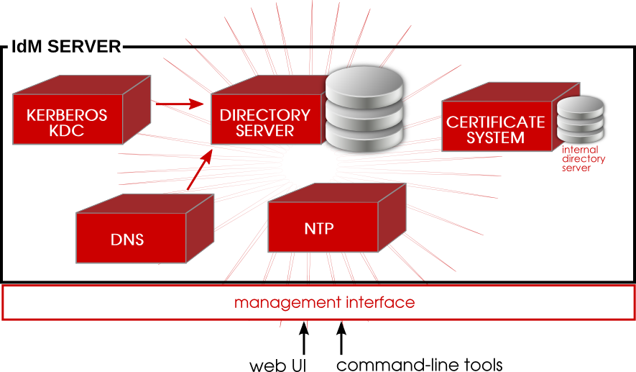

Multimaster Enterprise with Redundancy Overview
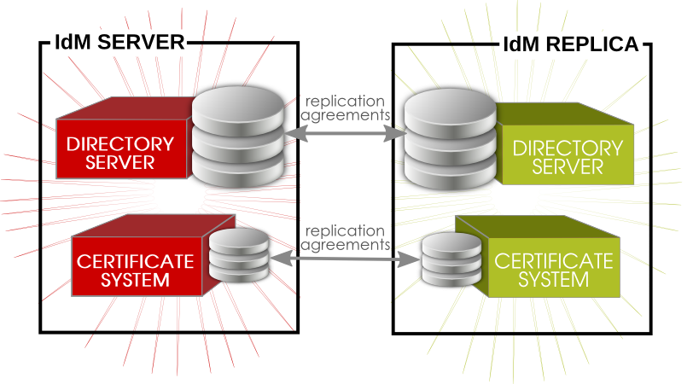

IdM Client Server Communication
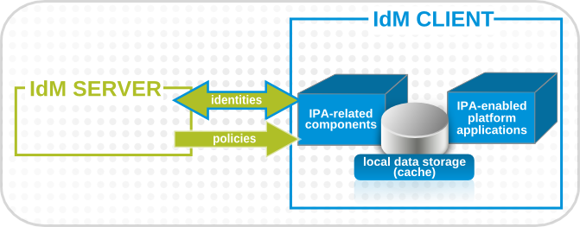

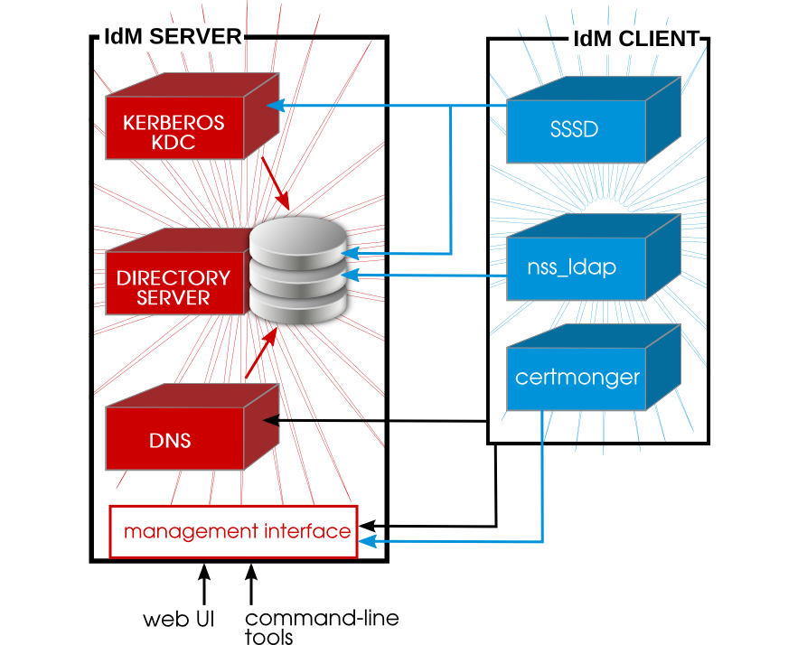

IdM Integration with Active Directory
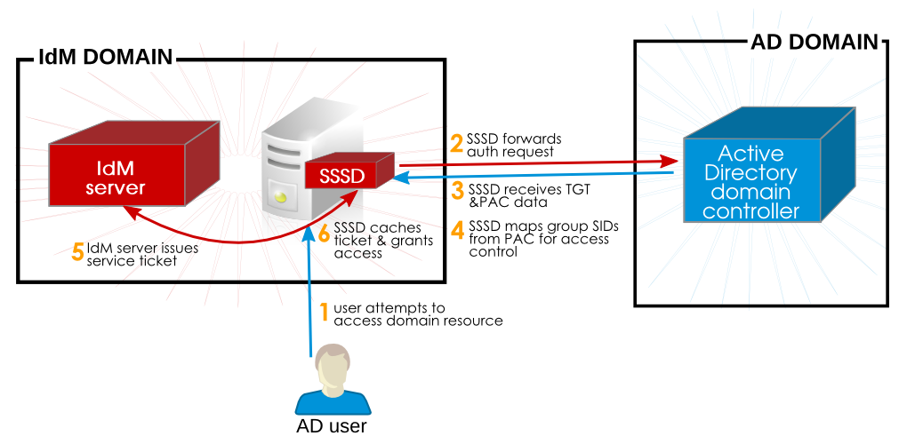

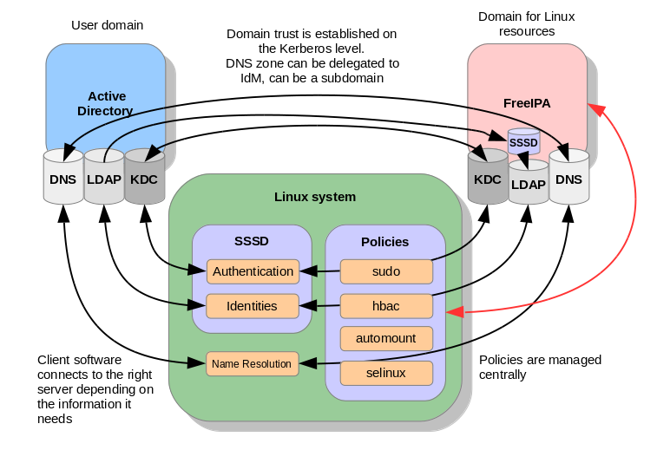

DNS Structure Overview
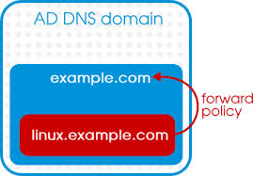

Appendix A – Acronyms
Table Appendix A-1 Acronyms
Acronym | Meaning
AD | Active Directory
CIFS | Common Internet File System
Firewalld | Firewall daemon (kernel based firewall)
GID | Group Identifier
GPO | Group Policy Object
IP | Internet Protocol
iSCSI | Internet Small Computer System Interface
LVM | Logical Volume Management
MTU | Maximum Transmission Unit
NFS | Network File System
OS | Operating System
OU | Organizational Unit
RHEL | Red Hat Enterprise Linux
SELinux | Security Enhanced Linux
STIG | Security Technical Implementation Guide
UID | User Identifier
VMDK | Virtual Machine Disk
XFS | X File System

